Task Support – New Employee Orientation
Onboarding Manager Benefits Forms
Latest Revision: 02/27/2024

Purpose
Welcome to NIH! As a new employee you may be entitled for certain benefits. This visual guide will illustrate and describe how to elect Health insurance, Life insurance, and TSP contribution through the Onboarding System. All elections made through Onboarding should be signed electronically and will be received and considered as official.

Significant Information
Benefit elections CANNOT be submitted prior to your entrance on duty date (EOD) and Designation of Beneficiary forms should NOT be submitted in Onboarding Manager.

Click on the carrot (>) beside the sections to expand.

Accessing Onboarding Manager

- Access your Onboarding Profile. Follow the address listed in your final offer letter and click ‘Employee Onboarding Checklist’. | 
- Next, click the option that bring you to USAstaffing.com. | 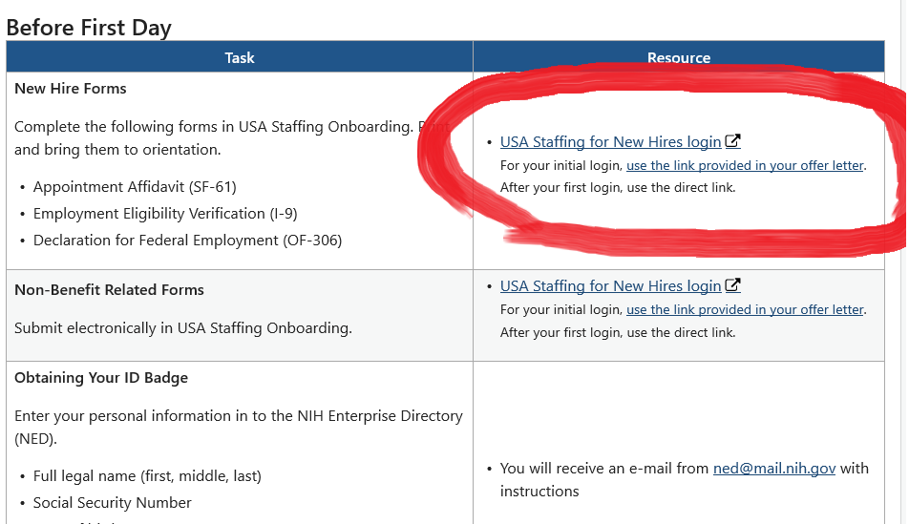
- Click Login with USAJOBS. | 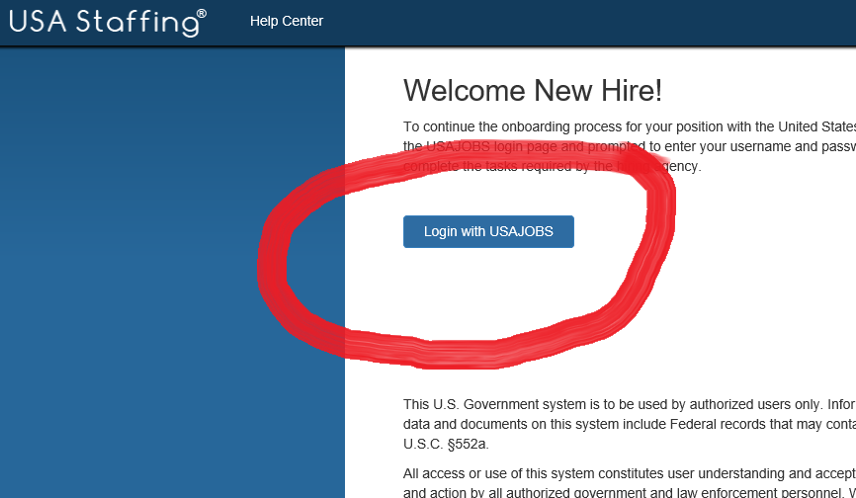
- After entering your email and password, USAJOBS will then send you a verification code to allow you to login. | 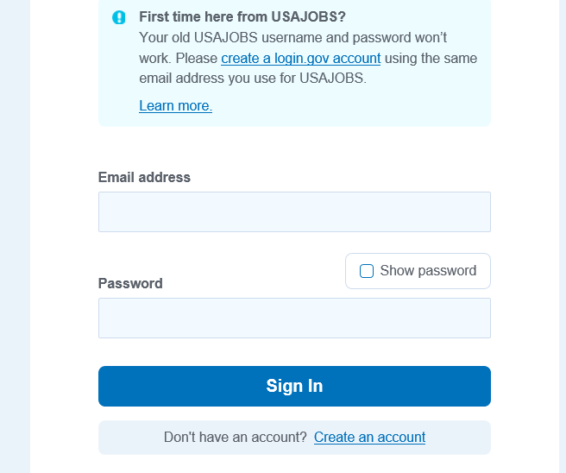

- Once you have accessed your specific profile, you will be prompted with the ‘New Hire Questionnaire’ – specifically the ‘Benefits’ portion which will consist of a Health, Life, TSP, and Beneficiary subsections.

Continue to the “New Hire Questionnaire – Benefits” section.

New Hire Questionnaire - Benefits

If you are brought to a list of ‘Tasks’ instead of the questionnaire, the very top of the list is the ‘New Hire Questionnaire’ which you will be able to access.
Everything that is entered in these subsections will then auto populate into the individual forms when you go to sign them later.
Below is the subsection of ‘Benefits’ and the four corresponding subsections.
Federal Employee Health Benefits (FEHB)
If you wish to waive health insurance, select that you do not want to participate in the FEHB.  If you wish to participate,  - Enter the health care provider name (BCBS, Aetna, etc.) in the section asking for the name of your new FEHB plan.  - Next, enter the correct 3-digit code that corresponds with the plan you wish to select in the section asking for the enrollment code.  Enrollment codes can be found on OPM.gov within the ‘Plan Information’ section labeled under Health Insurance. | 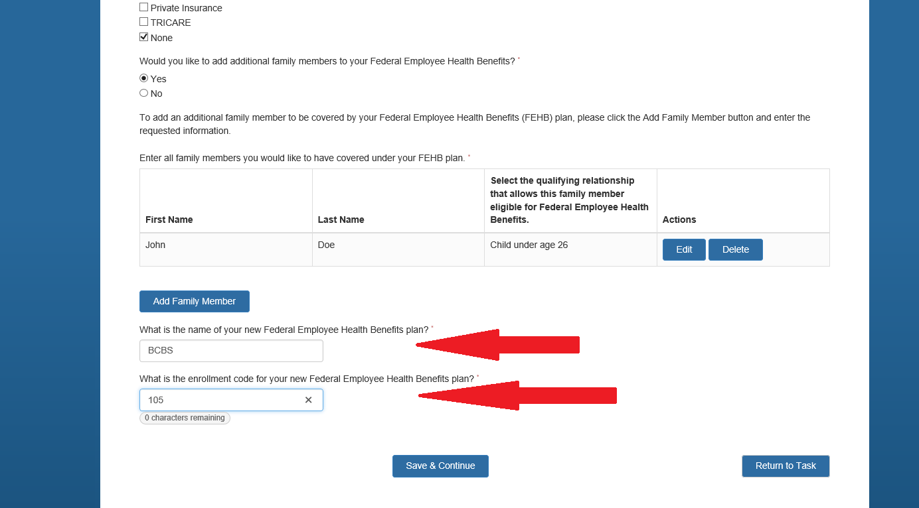
- For all dependents covered on your insurance, complete all their personal information, including if they are currently covered by insurance. Even if the answer is no, you must select ‘No’.  You may select the ‘Edit’ option next to their name once it is listed to verify there are no unanswered questions. | 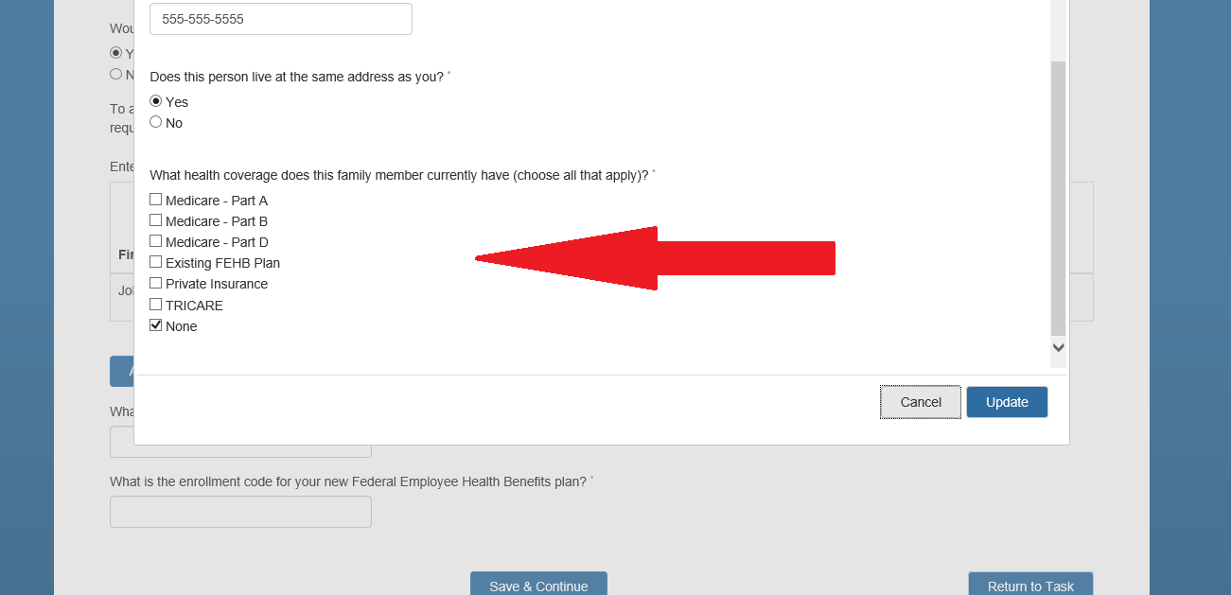

Federal Employees’ Group Life Insurance (FEGLI)
You are automatically enrolled in the ‘Basic’ level of coverage for life insurance.  If you wish to opt out, choose so when asked if you want to participate.  If you just wish to only have ‘Basic’ coverage (your salary rounded to the nearest thousand, plus $2,000), select ‘Yes’ and do not choose any additional options.  You may select any combination of additional options, but you must elect to remain enrolled in Basic coverage.  Optional Coverage Details  Option A – additional $10,000 of coverage  Option B – 1-5 multiples of your salary  Option C – 1-5 multiples on eligible family members ($5,000 per multiple for spouse and $2,500 per multiple for dependents.) | 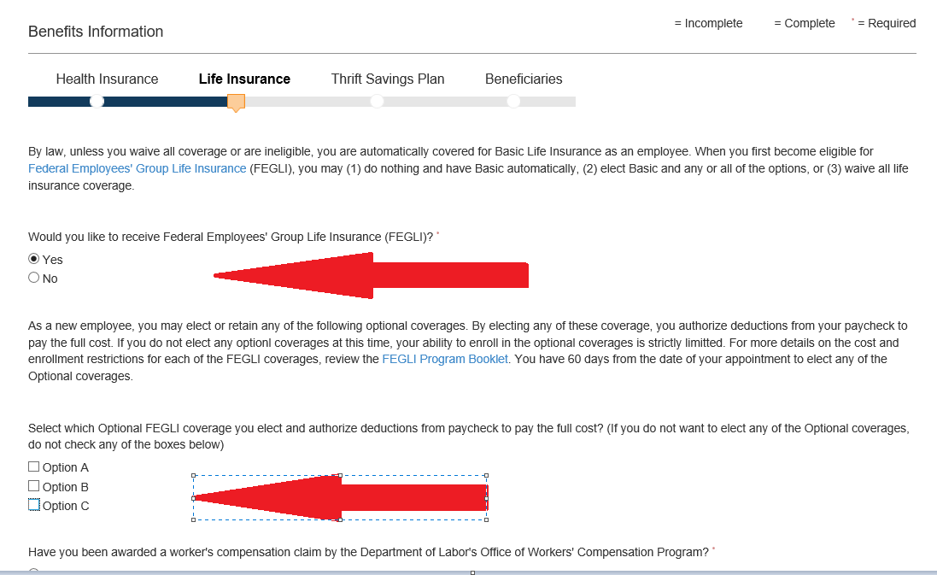

Thrift Savings Plan (TSP)
You are automatically contributing 5% of your bi-weekly paycheck to your TSP account.  If you do not want to contribute, please select the option to ‘Make No Contribution’.  If you wish to change your amount contributed or the type of contribution (Traditional vs Roth), select the option to change and enter in the amount. | 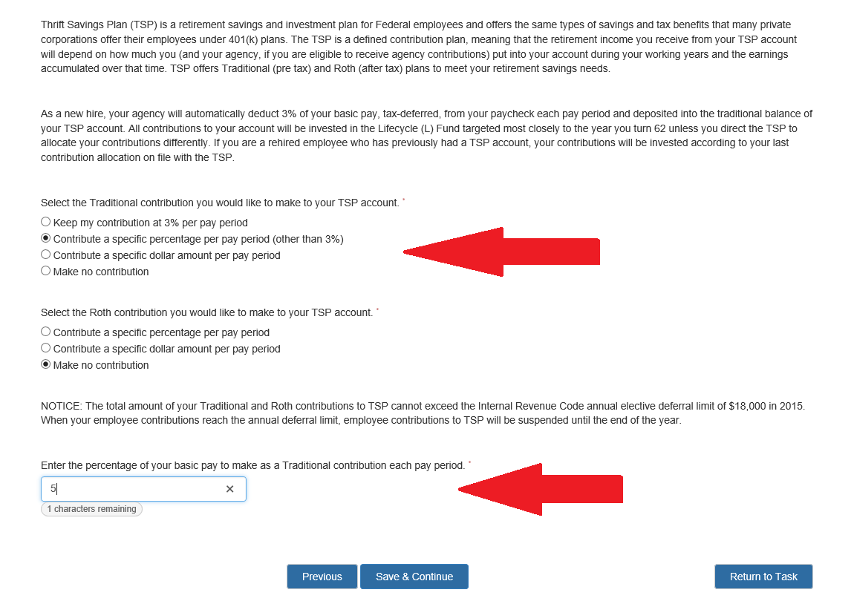

Upon completion of these sections, you will return to a “Task Details” page. Click “Close” to return to the main lists of tasks.
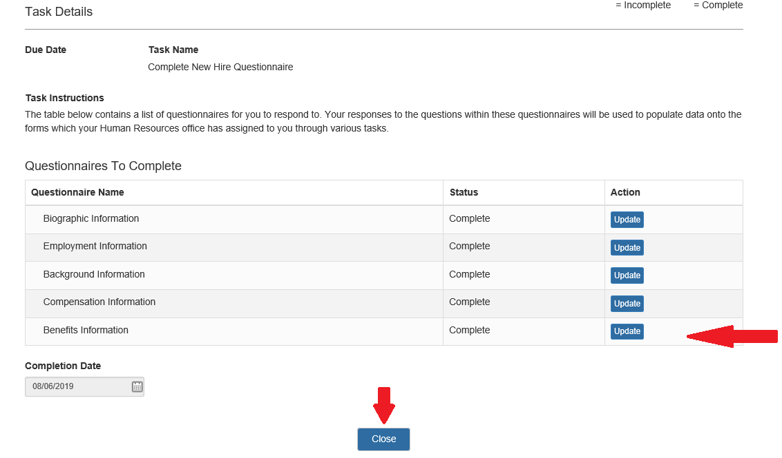
Continue to the “Review, Sign, and Submit Forms” section.

Review, Sign, and Submit Forms

On your list of tasks will be the three forms you will ultimately need to sign (SF-2809, SF-2817, TSP-1).  If they have been completed correctly you will be able to select them, prompting a PDF version of the corresponding form. | 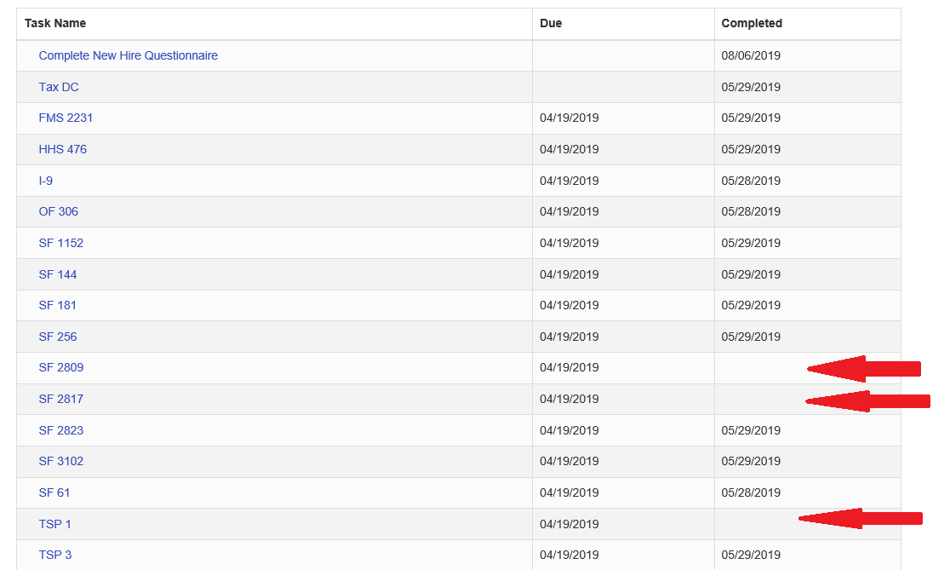
- Select the form you wish to sign. Again, this will prompt a PDF version of the form with all the previously entered information auto populated into the form. | 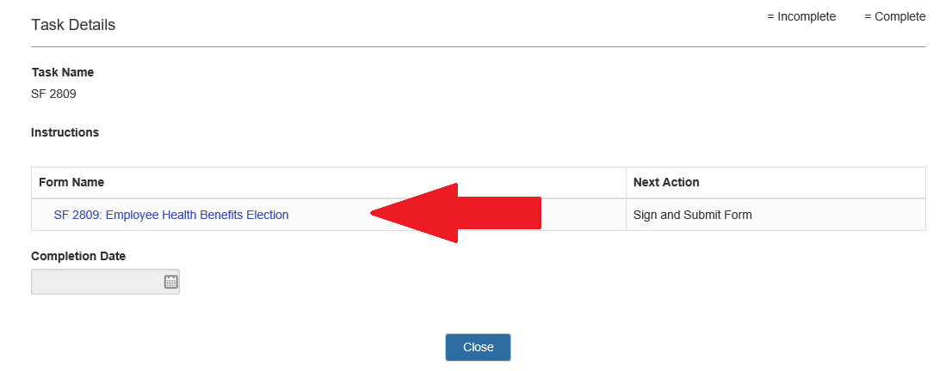
- Verify that all the information is correct and then scroll to the bottom of the form and click the option labeled ‘Confirm’. | 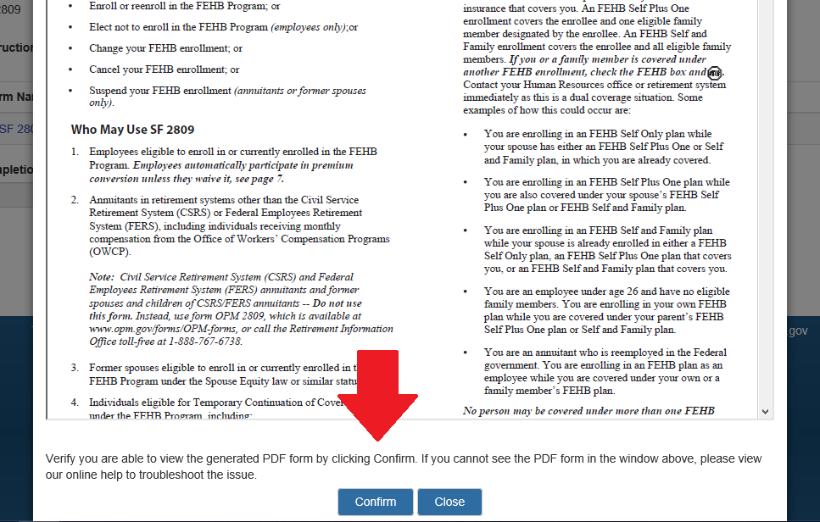
- Select ‘Sign and Submit’, lastly select ‘I Agree’ and the form will be complete. | 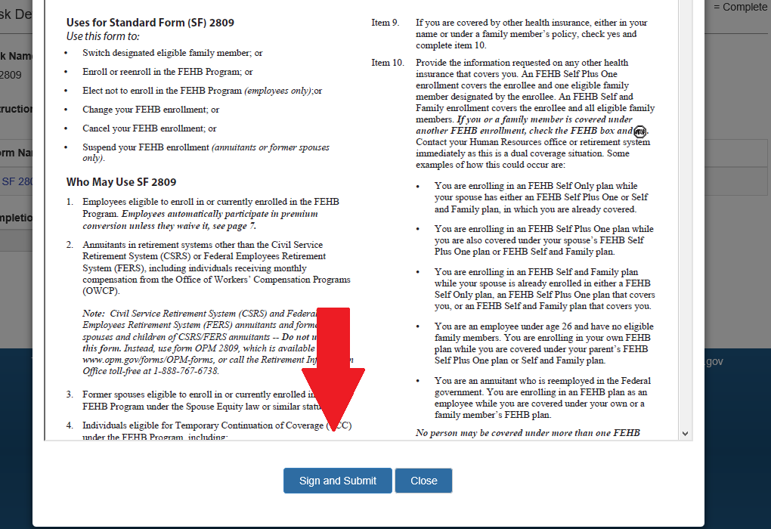
You will be brought back to the list of tasks.  - Verify there is a time stamp next to each of the previous forms you have just signed. | 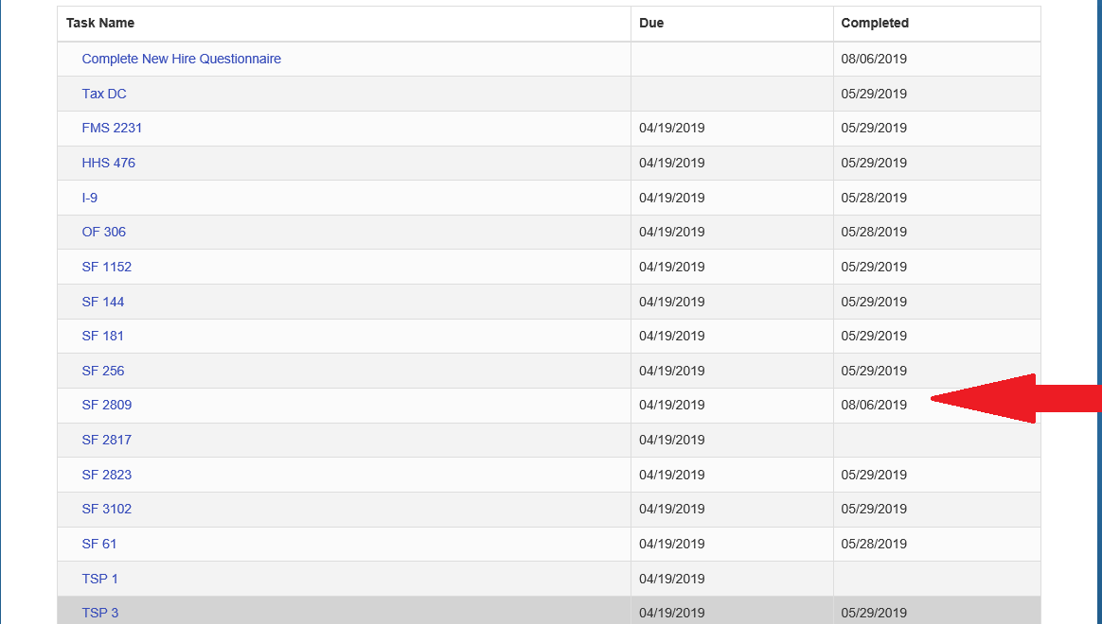

Issues Submitting Forms

If you are experiencing technical issues submitting your benefit elections, submit a ticket to the HR Systems Support (HRSS) helpdesk at https://hr.nih.gov/hr-systems.

If you experience issues submitting a ticket, email HRSystemsSupport@nih.gov.

Frequently Asked Questions (FAQs)

GENERAL
- Q: I am having trouble signing documents, what can I do?
A: If you are having trouble signing documents or having information save, try switching you’re your internet browser. Some browsers are set to reject the ‘Cookies’ needed to effectively complete the Onboarding process.
- Q: Where can I find help navigating USAS Onboarding Manager?
A: Navigate to the USA Staffing New Hire Help page.
- Q: Where can I find more information about submitting forms through USA Staffing Onboarding Manager?
A: Navigate to the USA Staffing Onboarding Manager FAQs.
- Q: Where can I learn more about my NIH benefits?
A: Navigate to the OHR Benefits page or OPM’s Fast Facts page to find additional resources on benefits that may be available to you.
- Q: How can I revise the benefit forms?
A: You will need to log in to the Onboarding Manager and click on “Complete New Hire Questionnaire.”
- Q: Why do I not see any benefit deductions and I have submitted my forms?
A: Log into your Onboarding Manager account and verify you have completed all the steps to submit your form to the Benefits Office. Refer to the guidance in the “Review, Sign, and Submit Forms” section of this task support guide. If you have successfully submitted your forms, it can take one to two pay cycles before you see the deduction reflected on your paycheck.
- Q: How do I know when the Benefits Office has received and processed my forms?
A: Log into Onboarding Manager (OM) and check the form status. The form status will change to “Complete” once the Benefits Office has acknowledge receipt of your election.

FEHB
- Q: When are my health insurance and TSP changes effective?
A: Health insurance and TSP contribution changes are effective on the first day of the following pay period in which they are signed.
- Q: If my current health insurance is set to expire prior to my new FEHB coverage beginning, would I need to list it on the form?
A: Yes, all coverage should be listed, regardless of expiration date.
- Q: Can I change my address listed on the SF 2809?
A: No, not in Onboarding Manager. You must email our team with your correct address so it can be updated outside of the Onboarding Manager system. Be sure to inform your Administrative Officer (AO) of the update as well.
- Q: Can I carry my FEHB into retirement?
A: Yes. You must be entitled to retire on an immediate annuity under a retirement system for civilian employees and have been continuously enrolled in any FEHB plan(s) for 5 years immediately preceding the date the annuity begins, or for the full period(s) of service since your first opportunity to enroll, if less than 5 years. Coverage as a family member on an FEHB plan counts toward the requirement.
- Q: When will I receive my health insurance card?
A: Your election will be processed and faxed to the FEHB carrier. It generally takes 7-14 business days for the health carrier to process and provide your health insurance card.
- Q: How can I access my health insurance?
A: You may contact your local health carrier and a representative will assist you in registering an account.
- Q: How can I access the Consumer Checkbook and FEHB Comparison Tool?
A: Consumer Checkbook: https://www.checkbook.org/newhig2/agency/hhs
A: FEHB Comparison Tool: https://www.opm.gov/healthcare-insurance/healthcare/plan-information/compare-plans/

FEDVIP
- Q: Can I enroll prior to completing my SF 2809?
A: Yes, but remember you must be eligible for FEHB in order to have dental or vision.
- Q: Can I see the plans available prior to creating an account?
A: Yes, you can use the comparison tool.
- Q: When does the FEDVIP coverage begin?
A: Dental and/or vision coverage begins the beginning of the pay period following enrollment.

FEGLI
- Q: Are there any preexisting health conditions that would affect my FEGLI premiums?
A: No.
- Q: How long do I need to be enrolled to carry FEGLI into retirement?
A: You must be enrolled for 5 years prior to retirement.

TSP
- Q: Can I make changes to contributions that I have already made? For example, I put 5% towards TSP last pay period but want it to be higher.
A: No. Prior contributions cannot be altered.

FSAFEDS
- Q: Can I have an HAS/HRA and an FSA?
A: No, you cannot have both.

